[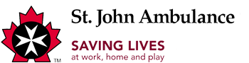](http://www.sja.ca/English)

Car Seat Program

|  |  |
| --- | --- |
| |  | | --- | | **Child Safety Seat Information Session**  **FREE • TWO - THREE HOURS** At selected SJA Centres, this FREE information session is intended to provide parents and caregivers information on how to correctly install a child safety seat and to transport children safely in a vehicle. It also provides an overview of the law in Alberta regarding occupant restraints and is taught by trained volunteers through the Community Services department of St John.   Edmonton Centre holds sessions every third Wednesday of the month from 7-9 pm. Please call 780 452 6161 ext 1225 to register.  Lethbridge Centre holds sessions every fourth Tuesday of the month from 7-9 pm except December) Please call 403 327 2847 ext 6102 to register. | |